<https://learn.microsoft.com/en-us/azure/devops/artifacts/get-started-maven?view=azure-devops>

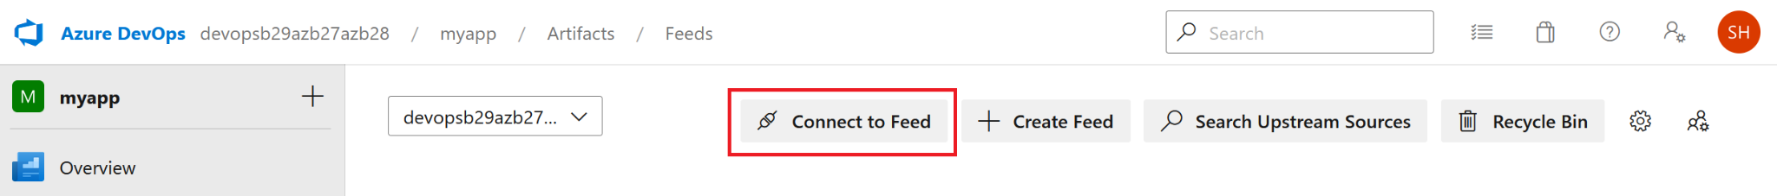

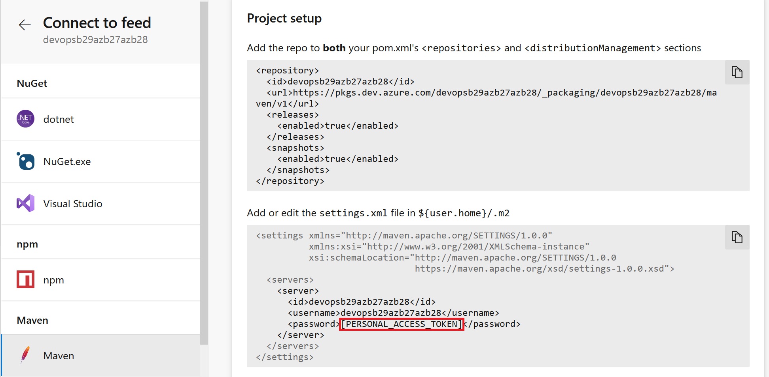

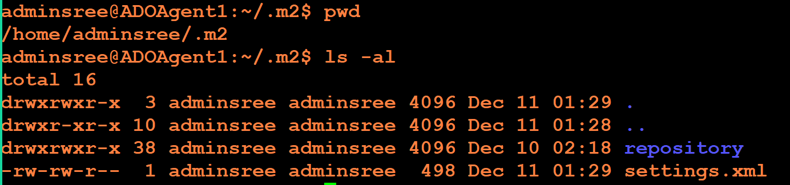

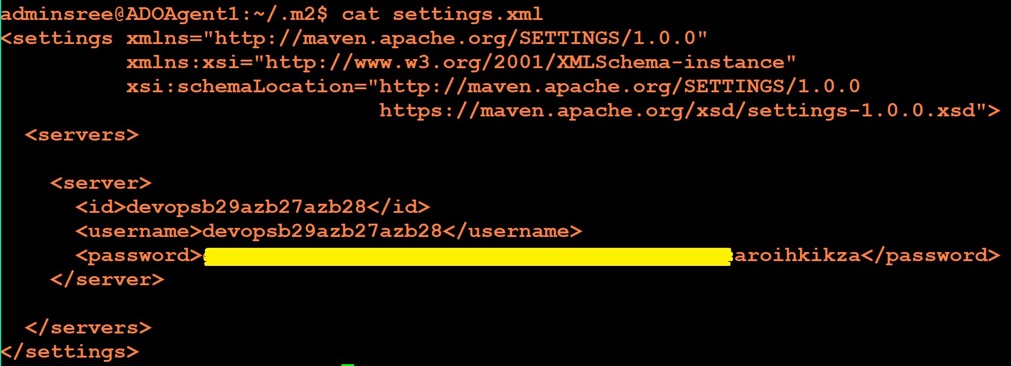

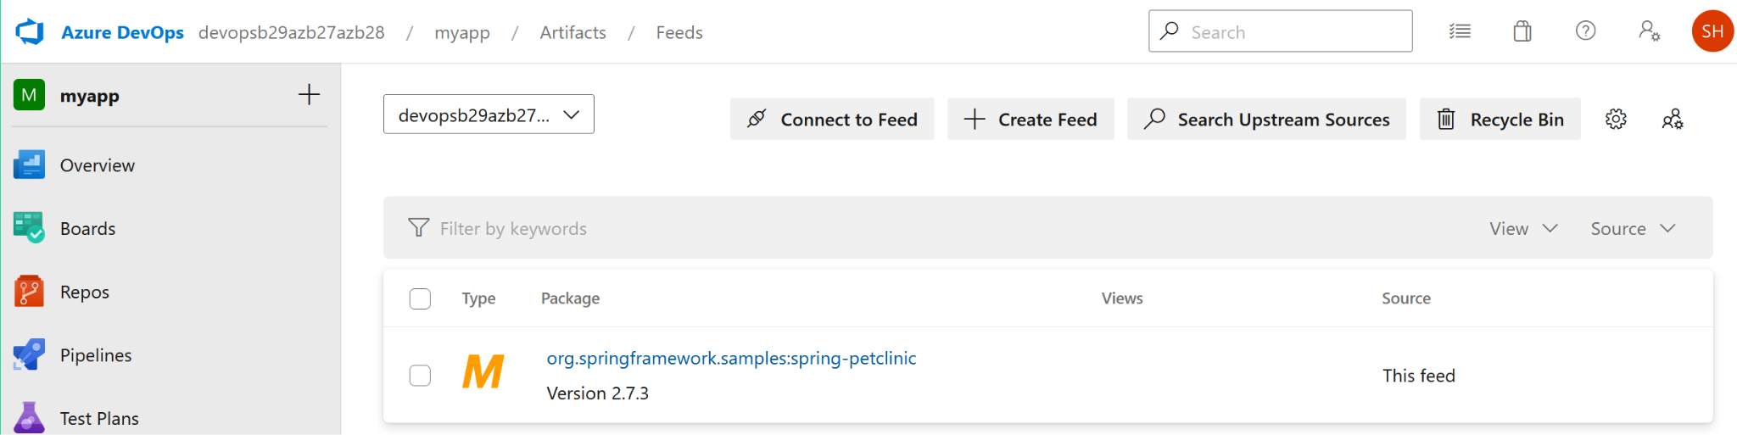

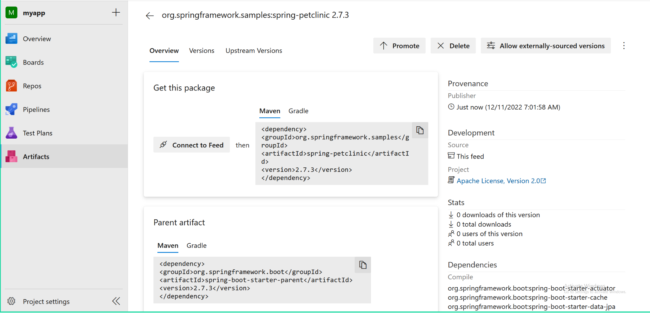

Running the pipeline multiple times will create a conflict as shown below. Its because maven is unable to overwrite the artifact in ADO Artifacts. Need to find the code for embed the POM file for incrementing the artifact version.

